Team_id: SC_24,

Mem 1 name: yusuf gamal elhusseiny
Mem 1 id: 2023170721
Mem 2 name: عبدالرحمن عادل محمد سعيد
Mem 2 id: 2023170337
Mem 3 name: مرام محمد السيد أحمد طه
Mem 3 id: 2023170568
Mem 4 name: يوسف احمد عبدالجواد اسماعيل
Mem 4 id: 2023170710
Mem 5 name: نغم صلاح مصطفي محمد الكسار
Mem 5 id: 2023170668
Mem 6 name: منه محمد زايد السيد عبد المجيد
Mem 6 id: 2023170639

E-LEARNING STUDENT PERFORMANCE PREDICTION

Introduction:
In this project, we use a dataset that contains information about students, their courses, and their performance. The dataset includes details like student scores, course data, and their activity on the learning platform.The main goal is to predict student performance using different regression models. By doing this, we can understand how different factors affect student results and which model gives better predictions.This kind of analysis is useful because it can help in identifying students who may need extra support and improve overall learning outcomes.

- Data Preprocessing:
First, the different datasets such as student information, courses, assessments, and VLE data were loaded and then merged together using common columns like student ID and course details to form one dataset. After that, missing values were handled by replacing some with 0 and filling others, especially categorical data, with the most common value. New features were also created to improve the data, such as a weighted score calculated from the score and its weight, and a total resources feature obtained from the VLE data. Unnecessary columns like IDs were removed to simplify the dataset, and finally feature scaling was applied using StandardScaler to make sure all numerical values are on a similar scale.

- Data Analysis:
The dataset contains several features such as score, weighted_score, number of previous attempts, studied credits, and total resources.A positive relationship was observed between score and weighted_score, since weighted_score depends directly on score.There is also a positive relationship between total_resources and score, as students who use more resources tend to achieve higher scores.A negative relationship may exist between number of previous attempts and performance, as students with more attempts may have lower scores.Some features such as gender and region showed weak relationships with other features.Overall, the analysis helped identify the most important features affecting student performance.
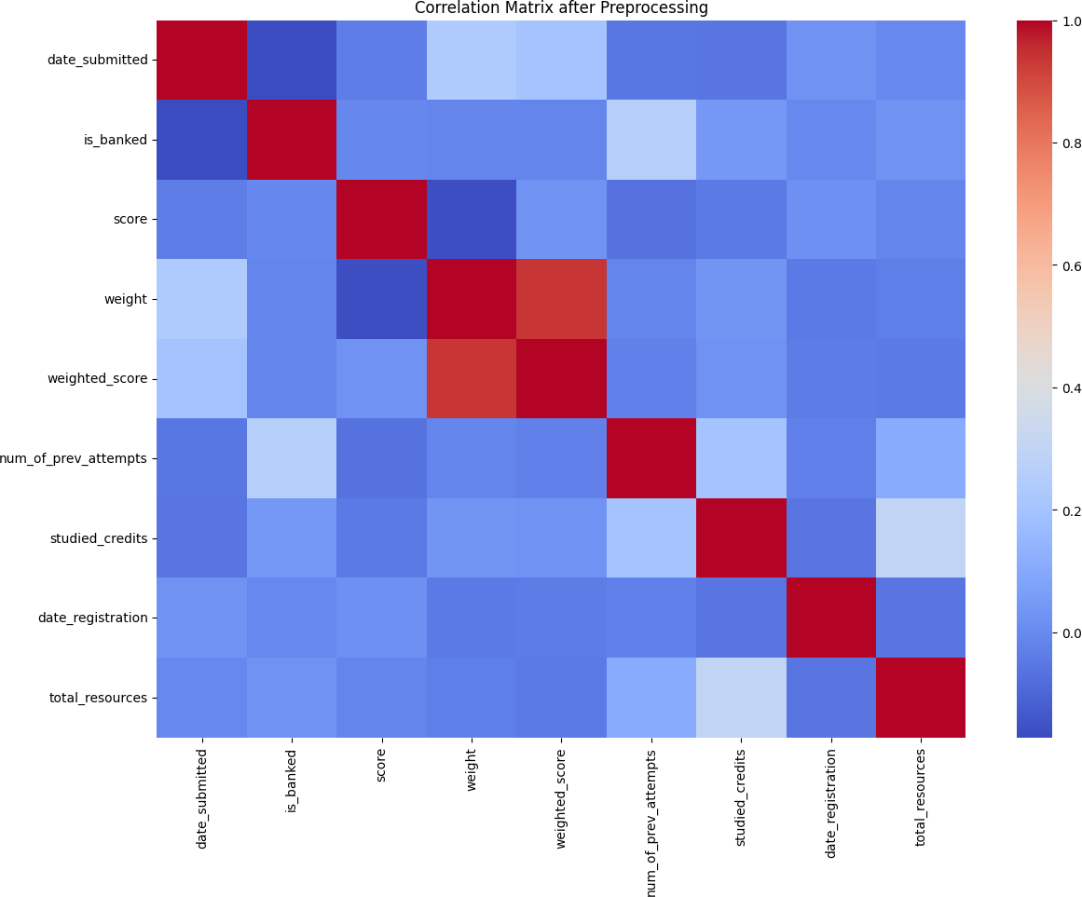

- Regression Techniques:
In this project, two regression-based machine learning models were used: Random Forest Regressor and XGBoost Regressor.Both models are ensemble learning methods capable of capturing complex non-linear relationships between features and the target variable. Random Forest builds multiple decision trees and averages their outputs, while XGBoost builds trees sequentially to reduce errors.The models were evaluated using R², Mean Squared Error (MSE), and Root Mean Squared Error (RMSE) through cross- validation.The results show that XGBoost performed better than Random Forest, achieving a higher R² score (0.7909) and a lower RMSE (8.6626), indicating more accurate predictions.This suggests that XGBoost is more suitable for this dataset as it captures the underlying patterns more effectively.

Model | R² | RMSE
Random Forest | 0.7816 | 8.8525
XGBoost | 0.7G0G | 8.6626

- Features Used:
The features used in building the regression models include weighted_score, weight, date_registration, date_submitted, total_resources, studied_credits, highest_education, age_band, gender, and assessment-related variables.Features such as student IDs (id_student, id_assessment), code_module, and code_presentation were discarded because they do not contribute meaningful information to prediction and act only as identifiers.

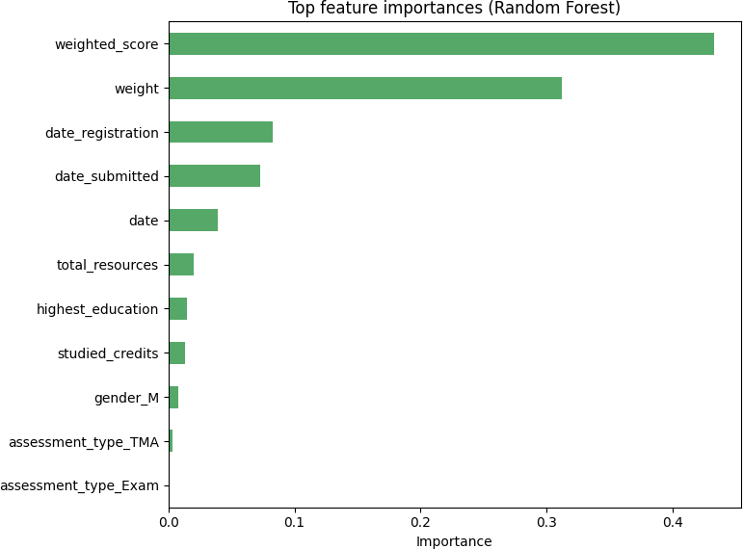

- Size of training and testing sets:
The dataset was split into training and testing sets using a 75/25 split.75% of the data was used for training the models, while 25% was used for testing their performance.No separate validation set was used; instead, cross-validation was applied during model evaluation to ensure reliable results.

- Further Techniques:
To improve the results, 5-fold cross-validation was used to get a more reliable evaluation of the models.Also, some model parameters were adjusted (like number of trees, depth, and learning rate) for both Random Forest and XGBoost to improve performance and reduce errors.These steps helped make the models more accurate and stable.

Conculsion:
In this phase of the project, regression models were used to predict the target variable. Two models were tested: Random Forest and XGBoost. XGBoost gave slightly better results with higher accuracy and lower error. At the beginning, it was expected that academic- related features like weighted_score would have the most effect, and this was confirmed by the results. Overall, the models showed good performance, and the results matched the initial expectations.

